Falcon User Manual

Version 1.0 | Release Date- 21/08/2026

Revision History
Paper copies are valid till the day they are printed. Please contact the author if you are not sure about the accuracy of the document.
Version No. | Date  (dd/mm/yyyy) | Details of Change | Prepared By | Reviewed By | Approved By
1.0 | 21/08/2026 | Falcon User Manual | Dishank Kumar | Gayatri Kulkarni | Smruti Shelke

TABLE OF CONTENTS

1. Open the Falcon Login Page 4
2. Click “Register Now” 5
3. Fill in the Registration Details 5
4. Registration Fields 6
5. Complete the Registration 6
6. Login After Successful Registration 7
7.1 Dashboard Overview 8
8. Raise a New Ticket 8
8.1 Enter Ticket Details 9
8.2 Select Ticket Priority 10
8.3 Assign the Ticket to a Department 10
8.4 Select the Location 11
8.5 Add Description and Attachment 12
9. Example: Raise an IT Ticket for a Keyboard Issue 12
10. Complete User Flow 13
11.Falcon – Password Reset User Guide 14
Step 11.1 – Open the Login Page 14
Step 11.2 – Open the Forgot Password Page 15
Step 11.3 – Enter Login ID or Email 15
Step 11.4 – Reset Your Password 16
Step 11.5 – Change Password 17
Step 11.6 – Password Reset Successful 18
Step 11.7 – Login with the New Password 18

Falcon User Manual
User Registration and Login
Step-by-step guide for creating a new account and signing in

Purpose: This manual explains how a new user can register in Falcon and then log in successfully using the registered credentials.

1. Open the Falcon Login Page
Open the Falcon application. The Login page will be displayed with fields for User ID and Passwod.
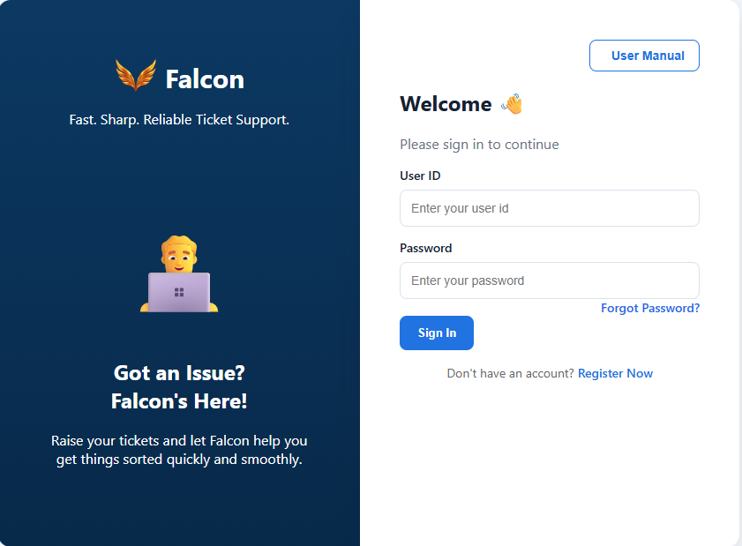

For a first-time user, registration must be completed before attempting to sign in.

2. Click “Register Now”
On the Login page, locate the “Register Now” link below the Sign In button. The registration option is highlighted in red in the screenshot below.
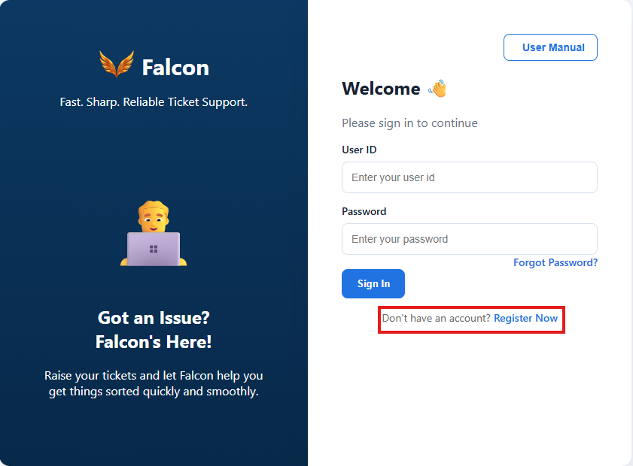
Figure 1: Falcon Login page – click “Register Now” to create a new account.

3. Fill in the Registration Details
After clicking “Register Now”, the Create Account page will open. Enter the required user information in the available fields.
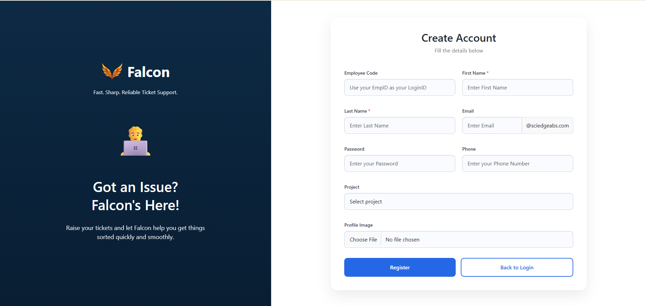
Figure 2: Falcon Create Account / Registration page.

4. Registration Fields
Note:- (*) Fields are mandatory.
Field | Description
Employee Code* | Enter your Employee ID / Employee Code. This will be used as your Login ID.
First Name * | Enter your first name. This is a mandatory field.
Last Name * | Enter your last name. This is a mandatory field.
Email* | Enter your official email name. The screen shows the organization domain @sciedgeabs.com.
Password* | Create a password for your Falcon account.
Phone* | Enter your phone number.
Project* | Select the applicable project from the project list.
Profile Image (optional) | Choose a profile image if required.

5. Complete the Registration
- Verify that all entered details are correct.
- Submit the registration form using the registration/create-account button available at the bottom of the page.
- Wait for the successful registration confirmation.

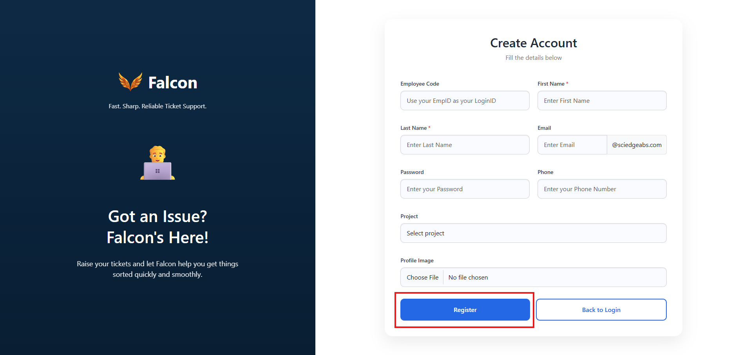

6. Login After Successful Registration
Once registration is completed successfully, return to the Falcon Login page.
- Enter your Employee Code / Login ID in the User ID field.
- Enter the password created during registration.
- Click “Sign In”.
Important: New users should complete the registration process first. After successful registration, the same registered Login ID and password can be used to access Falcon.
Quick Process Summary
Login Page → Register Now → Fill User Details → Complete Registration → Return to Login → Sign In
7. Dashboard After Successful Login
After the user registers successfully and logs in with the registered User ID and password, the Falcon Dashboard is displayed. The Dashboard provides a quick overview of ticket activity and allows the user to raise and track tickets.
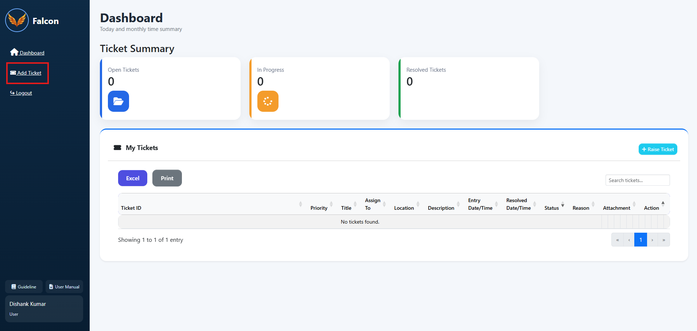
Figure 3: Falcon Dashboard displayed after successful login.

7.1 Dashboard Overview
Note:
- Ticket Summary shows the current number of Open Tickets, In Progress tickets, and Resolved Tickets.
- The My Tickets section displays the user’s ticket history and current ticket information.
- The user can search the ticket list and use the available Excel or Print options when required.
- To create a new support ticket, click Add Ticket from the left-side menu or Raise Ticket from the dashboard.

8. Raise a New Ticket
To report an issue, click the “Add Ticket” option highlighted on the Dashboard. The Raise New Ticket screen will open.
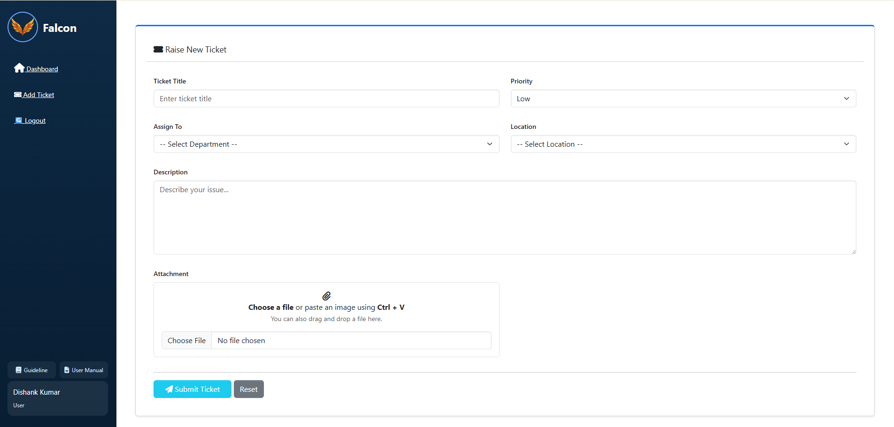
Figure 4: Raise New Ticket form.

8.1 Enter Ticket Details
Field | What to Enter | Example
Ticket Title | Enter a short and clear title describing the issue. | Keyboard is not working
Priority | Select the priority according to the impact/urgency of the issue. | Medium
Assign To | Select the department responsible for handling the ticket. | IT
Location | Select where the issue is occurring. | Office or WFH
Description | Enter complete details about the issue so the assigned department can understand it clearly. | Keyboard is not responding while working. Please check and resolve the issue.
Attachment | Attach supporting files/screenshots. You can choose a file, drag and drop it, or paste an image using Ctrl + V. | Screenshot of the keyboard/error, if available

8.2 Select Ticket Priority
Open the Priority dropdown and select the appropriate priority. The available options are Low, Medium, High, and Blocker. Choose the level based on the urgency and impact of the reported issue.
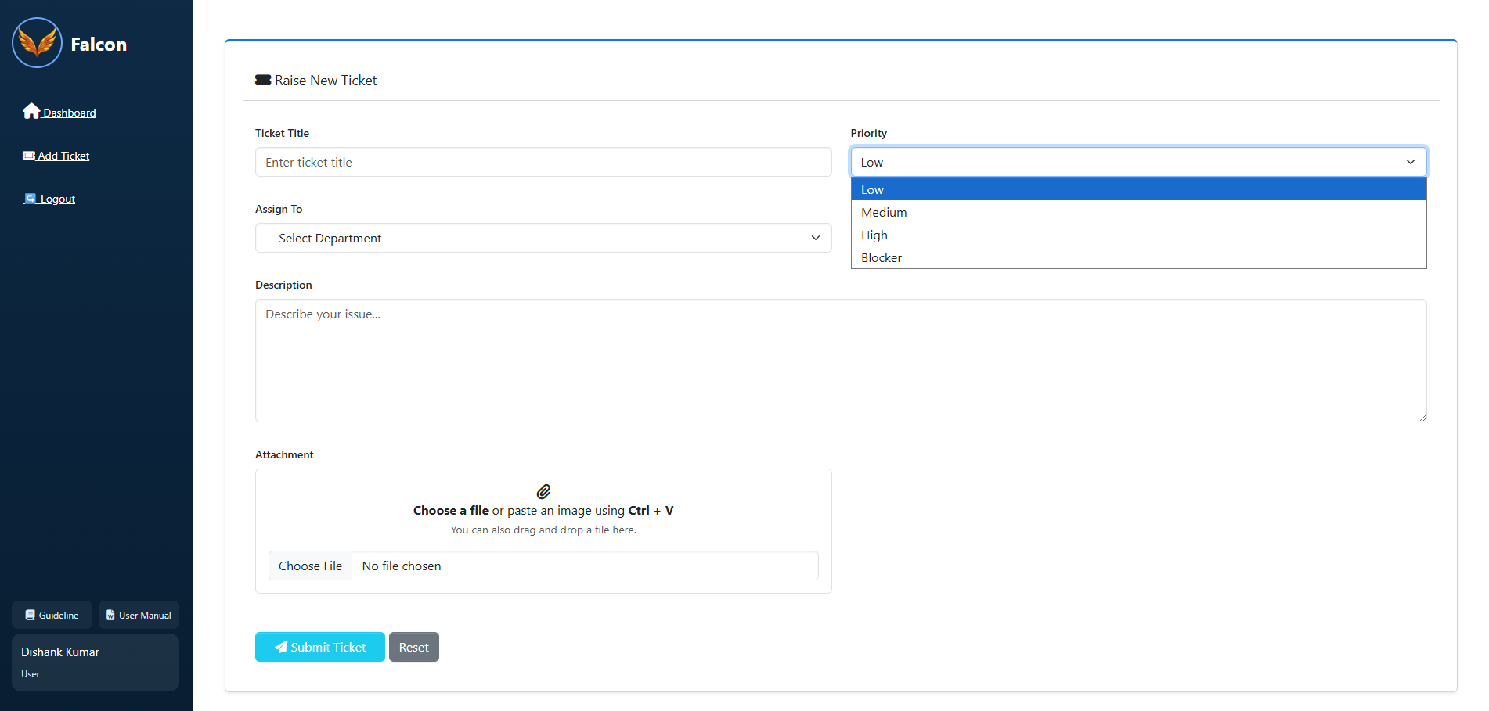
Figure 5: Priority options – Low, Medium, High, and Blocker.

8.3 Assign the Ticket to a Department
Open the Assign To dropdown and select the department that should handle the issue. For an IT-related issue such as “Keyboard is not working”, select the IT department.
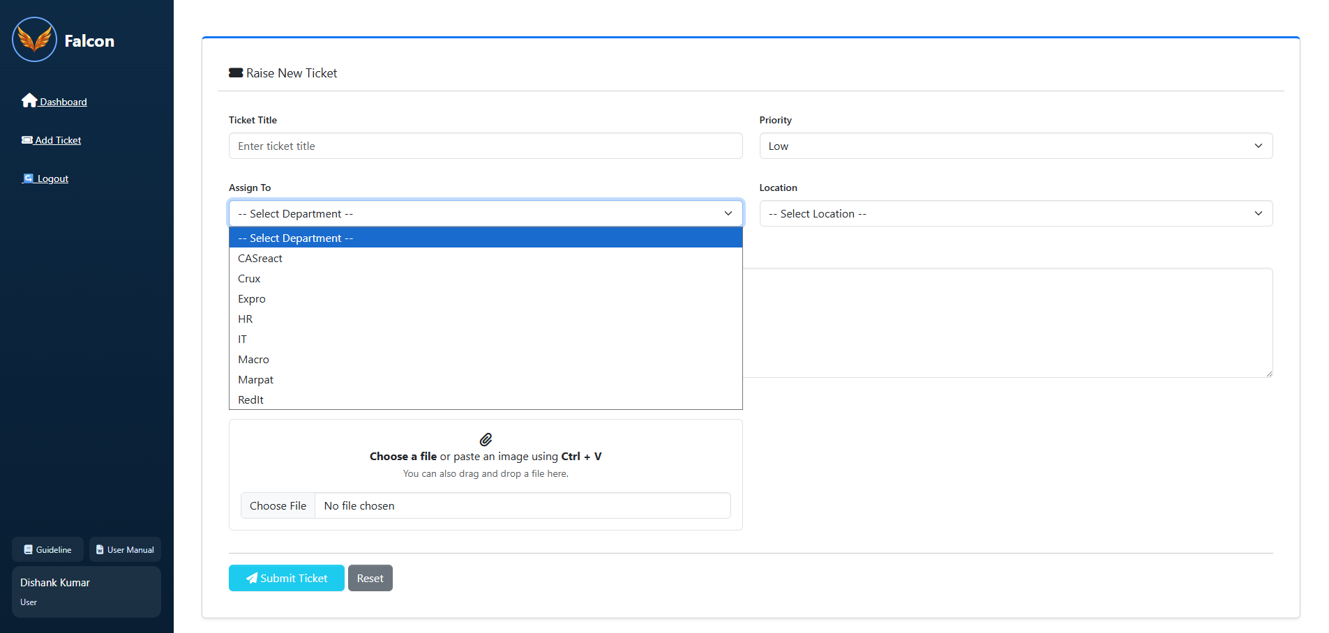
Figure 6: Assign To department selection. For the example issue, select IT.

8.4 Select the Location
Select the location where the issue is occurring. The available options shown are Office and WFH (Work From Home).
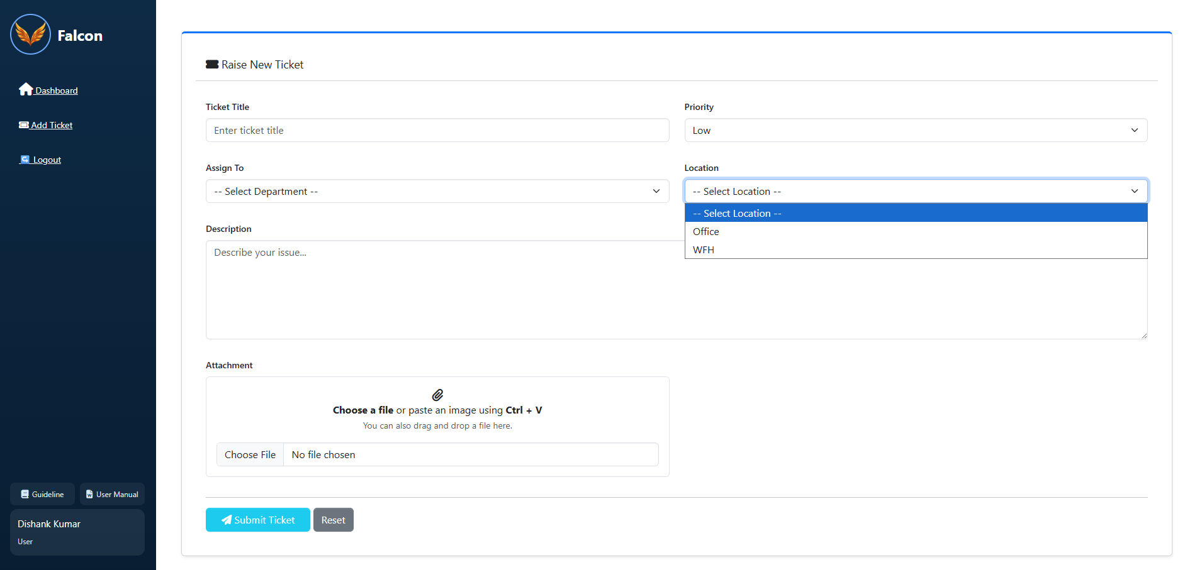
Figure 7: Location selection – Office or WFH.

8.5 Add Description and Attachment
In the Description field, explain the issue in sufficient detail. Add relevant information such as what is not working, when the issue started, and any message or behavior observed.
If a screenshot or supporting file is available, attach it using the Attachment section. The user can choose a file, drag and drop a file, or copy a screenshot and paste it directly using Ctrl + V.

9. Example: Raise an IT Ticket for a Keyboard Issue
Ticket Title: Keyboard is not working
Priority: Medium
Assign To: IT
Location: Office (or WFH if the issue occurs while working from home)
Description: Keyboard is not responding while working. Please check and resolve the issue.
Attachment: Attach or paste a screenshot if it helps explain the issue.
After all required details are entered, submit/raise the ticket using the button provided at the bottom of the form. The created ticket will then appear in the ticket list/history, where its progress can be tracked from the Dashboard.
Figure 8: Submit Ticket.
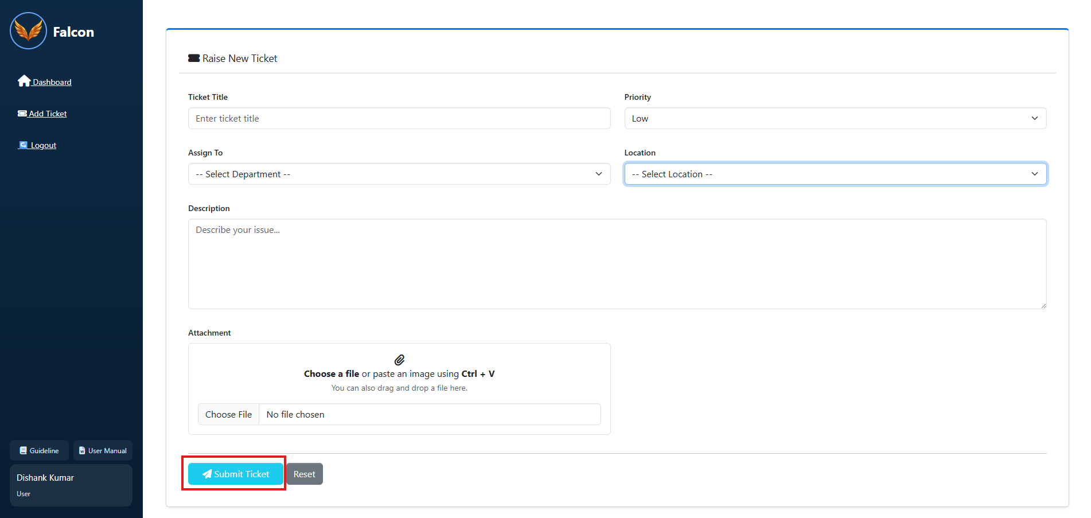

10. Complete User Flow
Register Now → Create Account → Login → Dashboard → Add Ticket → Enter Ticket Details → Select Priority → Assign Department → Select Location → Add Description/Attachment → Raise Ticket → Track Ticket Status/History

11.Falcon – Password Reset User Guide
How to reset your password using Login ID or Email
This guide explains the complete Forgot Password process in Falcon. Users can reset their password by selecting Forgot Password from the Login page, providing their Login ID or Email, and setting a new password.

Step 11.1 – Open the Login Page
On the Falcon Login page, enter your User ID and Password. If you have forgotten your password, click the “Forgot Password?” option.
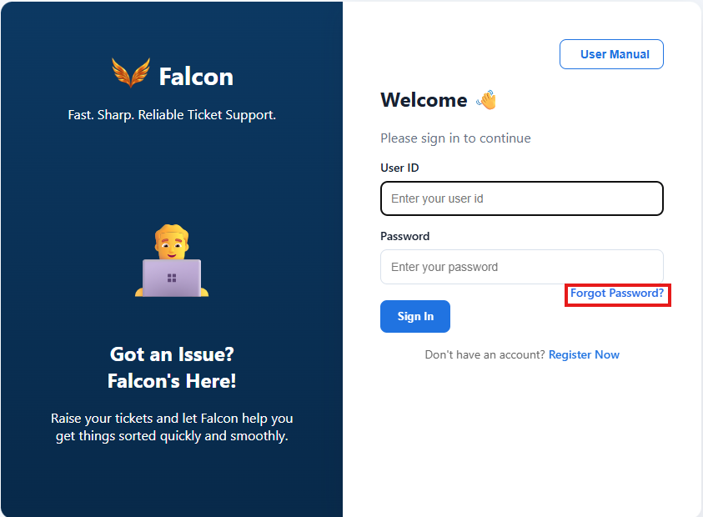

Step 11.2 – Open the Forgot Password Page
After selecting “Forgot Password?”, Falcon opens the password recovery page. The page asks for your Email / User ID so the system can identify your account.
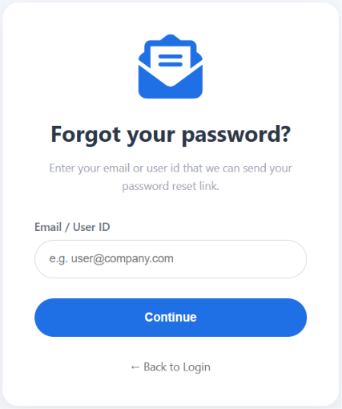

Step 11.3 – Enter Login ID or Email
Enter either your Falcon Login ID or your registered Email address in the “Email / User ID” field. Then click the “Continue” button.
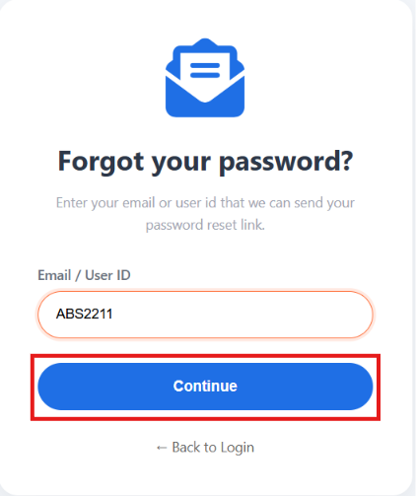

Step 11.4 – Reset Your Password
After the account is verified, the Reset Password page is displayed. Enter your new password in the “New Password” field and enter the same password again in the “Re-enter Password” field. The password strength indicator helps you understand the strength of the new password.

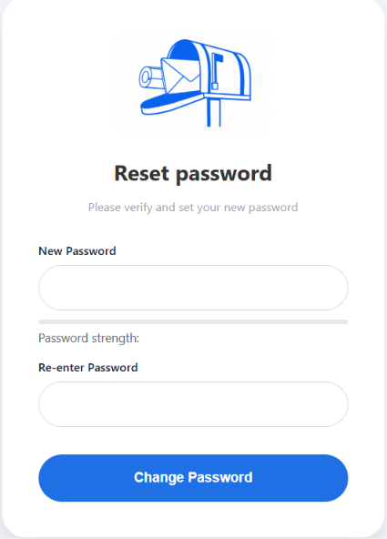

Step 11.5 – Change Password
Once both password fields are completed and the new password meets the required validation rules, click “Change Password”. Falcon processes the password change.
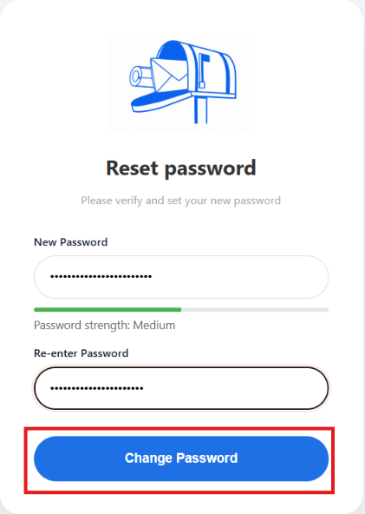

Step 11.6 – Password Reset Successful
After the password is successfully changed, a success message is displayed. The user is then taken back to the Login page.

Step 11.7 – Login with the New Password
On the Login page, enter your Login ID and the newly created password, then click “Sign In” to access Falcon.
Password Reset Flow
• Login Page → Forgot Password?
• Enter Login ID or Email → Continue
• Reset Password → Enter and confirm new password
• Change Password → Success message
• Return to Login → Sign in with the new password
Note :- Please reach out to your Process Manager in case of any queries or any issues.

Let’s Start Using Falcon 👨‍💻 With Open This
Link : http://timetracker.sciedge.in/

